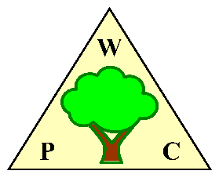
WOODPLUMPTON PARISH COUNCIL
AGENDA for MEETING TO BE HELD IN

THE PARISH ROOMS, REAR OF ST ANNE’S CHURCH WOODPLUMPTON ROAD, PRESTON

ON MONDAY 16 December 2024 at 7.00pm

- APOLOGIES
Members are reminded that apologies should be given in advance of the meeting and will be noted in the Minutes. If a Councillor is absent for 6 consecutive months, an apology must be approved by the Council, prior to the 6 months elapsing or the Councillor will be disqualified.
- CATFORTH TRAFFIC CALMING SCHEME
A number of objections were received to the Catforth Traffic calming Scheme. LCC have now written to the Parish Council concerning the path forward. This meeting has been convened to discuss our response to LCC.

- DATE OF NEXT MEETING
Members are requested to note that the next meeting is scheduled to take place on Monday 20th January 2025 at 7.00 in the Parish Rooms.

END

